**TITLE-1:-**

**To predict the weather forecast by using Artificial Neural Network [ANN] and comparing it with Support Vector Machine [SVM] for improving the accuracy.**

**Table 1-**The various datasets Mean , standard deviation and std. Error mean of Artificial Neural Network [ANN] and Support Vector Machine [SVM].

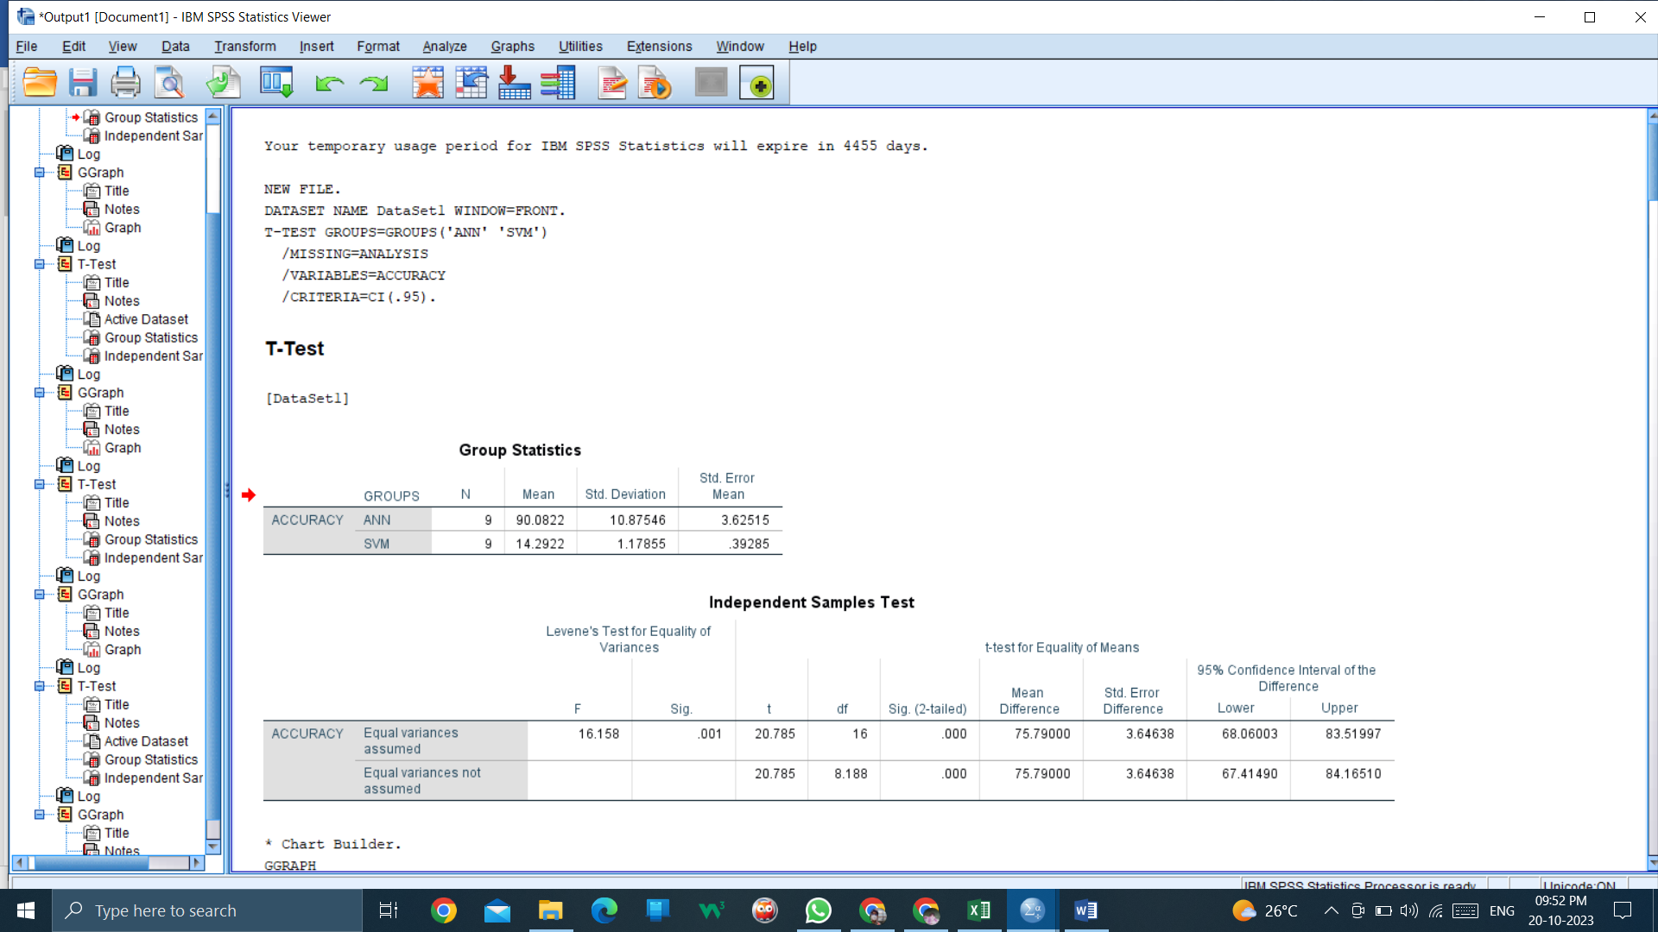

**Table 2- Independent Sample Test**

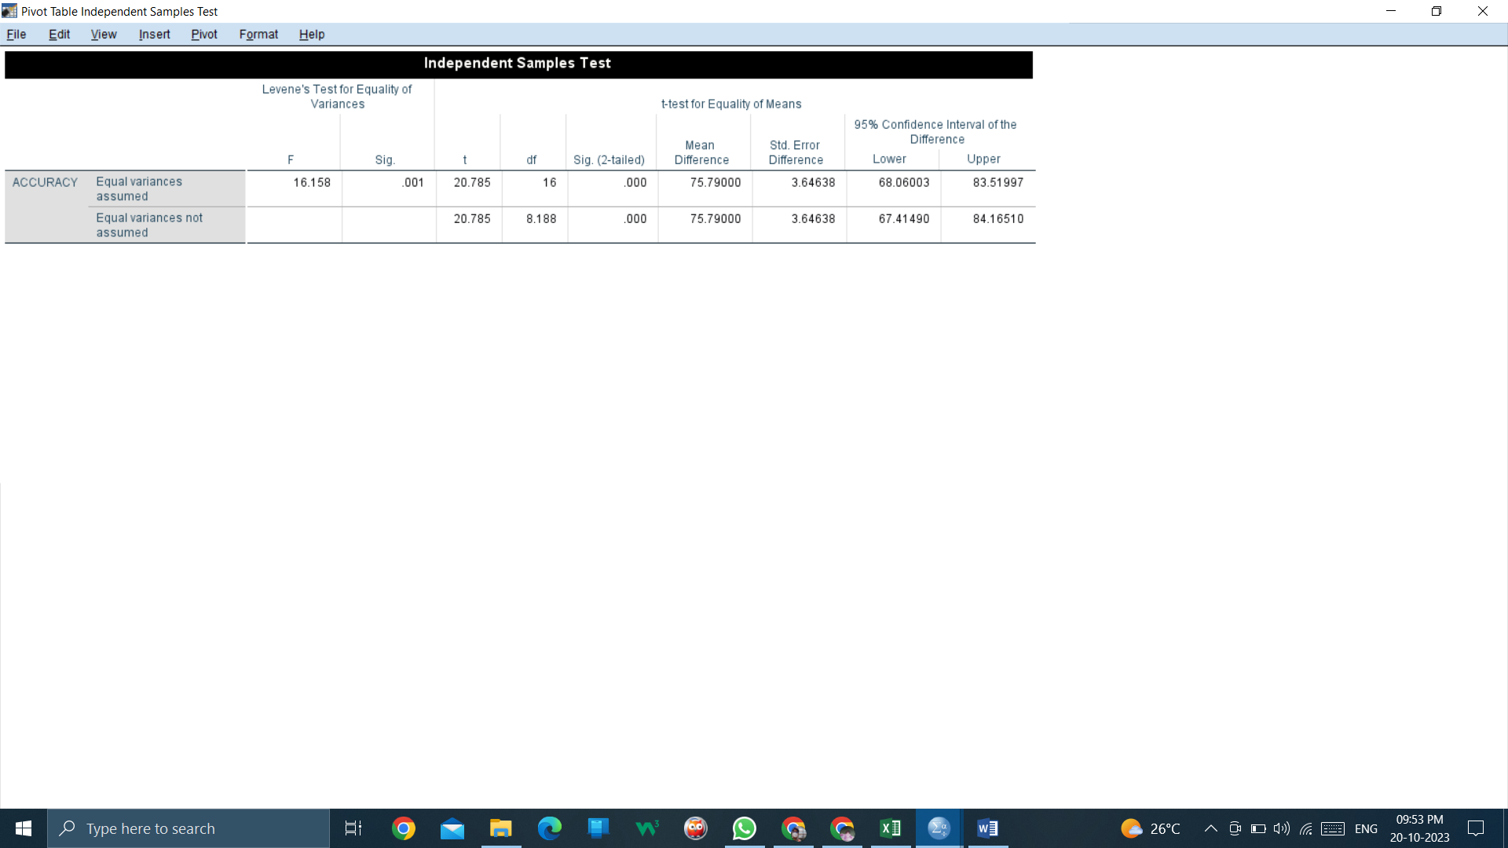

**Table 3-Bar Graph of Artificial Neural Network [ANN] and Support Vector Machine [SVM].**

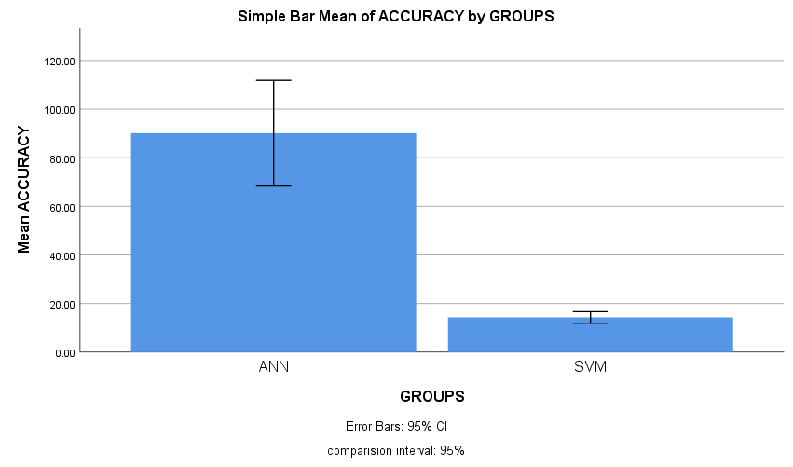

**TITLE-2:-**

**To predict the weather forecast by using Artificial Neural Network [ANN] and comparing it with Numerical Weather Prediction(NWP) Model for improving the accuracy.**

**Table 1-**The various datasets Mean, Standard deviation and std. Error means of Artificial Neural Network [ANN] and Numerical Weather Prediction [NWP].

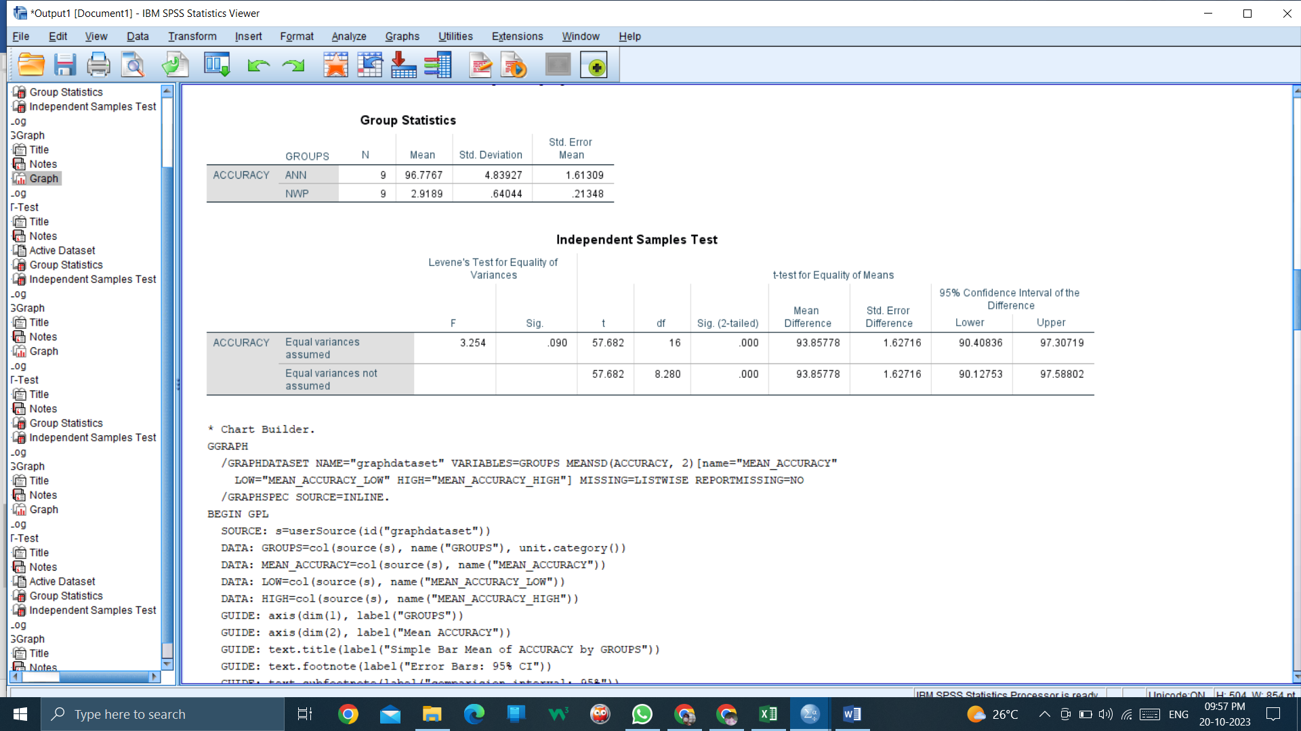

**Table 2- Independent Sample Test**

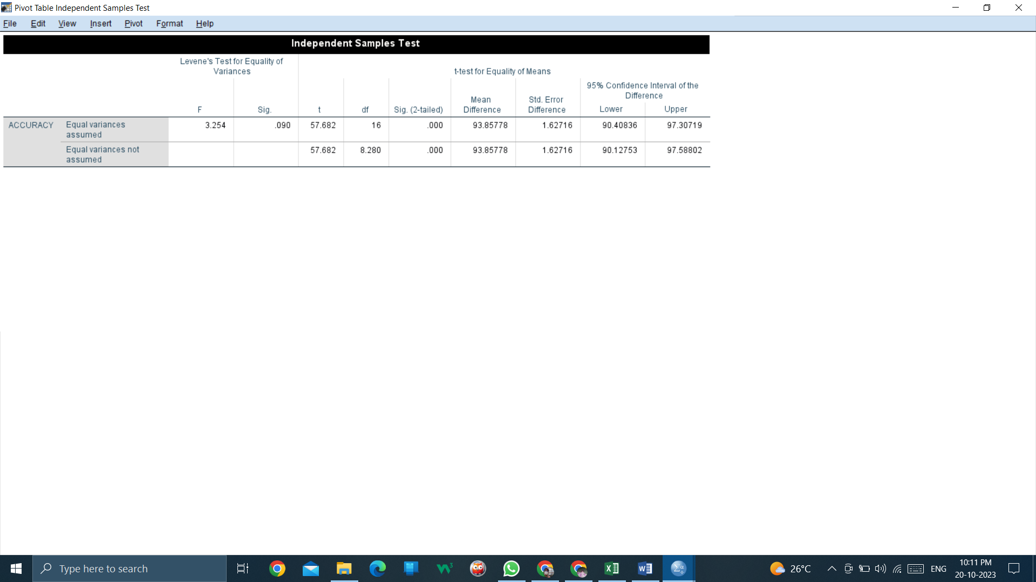

**Table 3-**Bar Graph of Artificial Neural Network [ANN] and Numerical Weather Prediction [NWP].

**GGraph:**

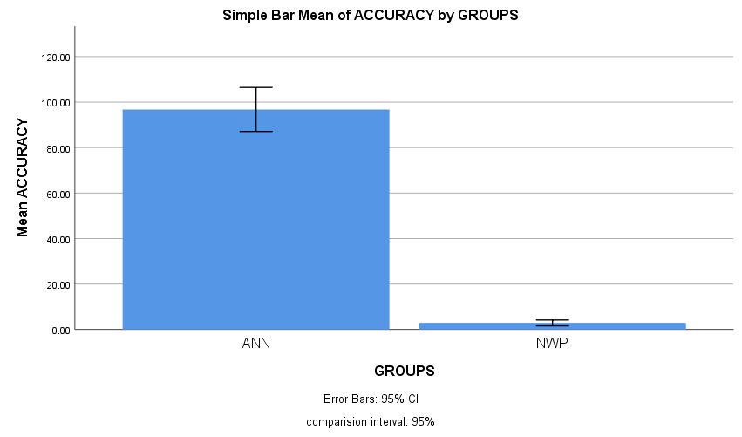

**TITLE-3:-**

**To predict the weather forecast by using Artificial Neural Network [ANN] and comparing over with Logistic Regressor (LR) for improving the accuracy.**

**Table 1-**The various datasets Mean, standard deviation and std. Error means of Artificial Neural Network [ANN] and Logistic Regressor [LR].

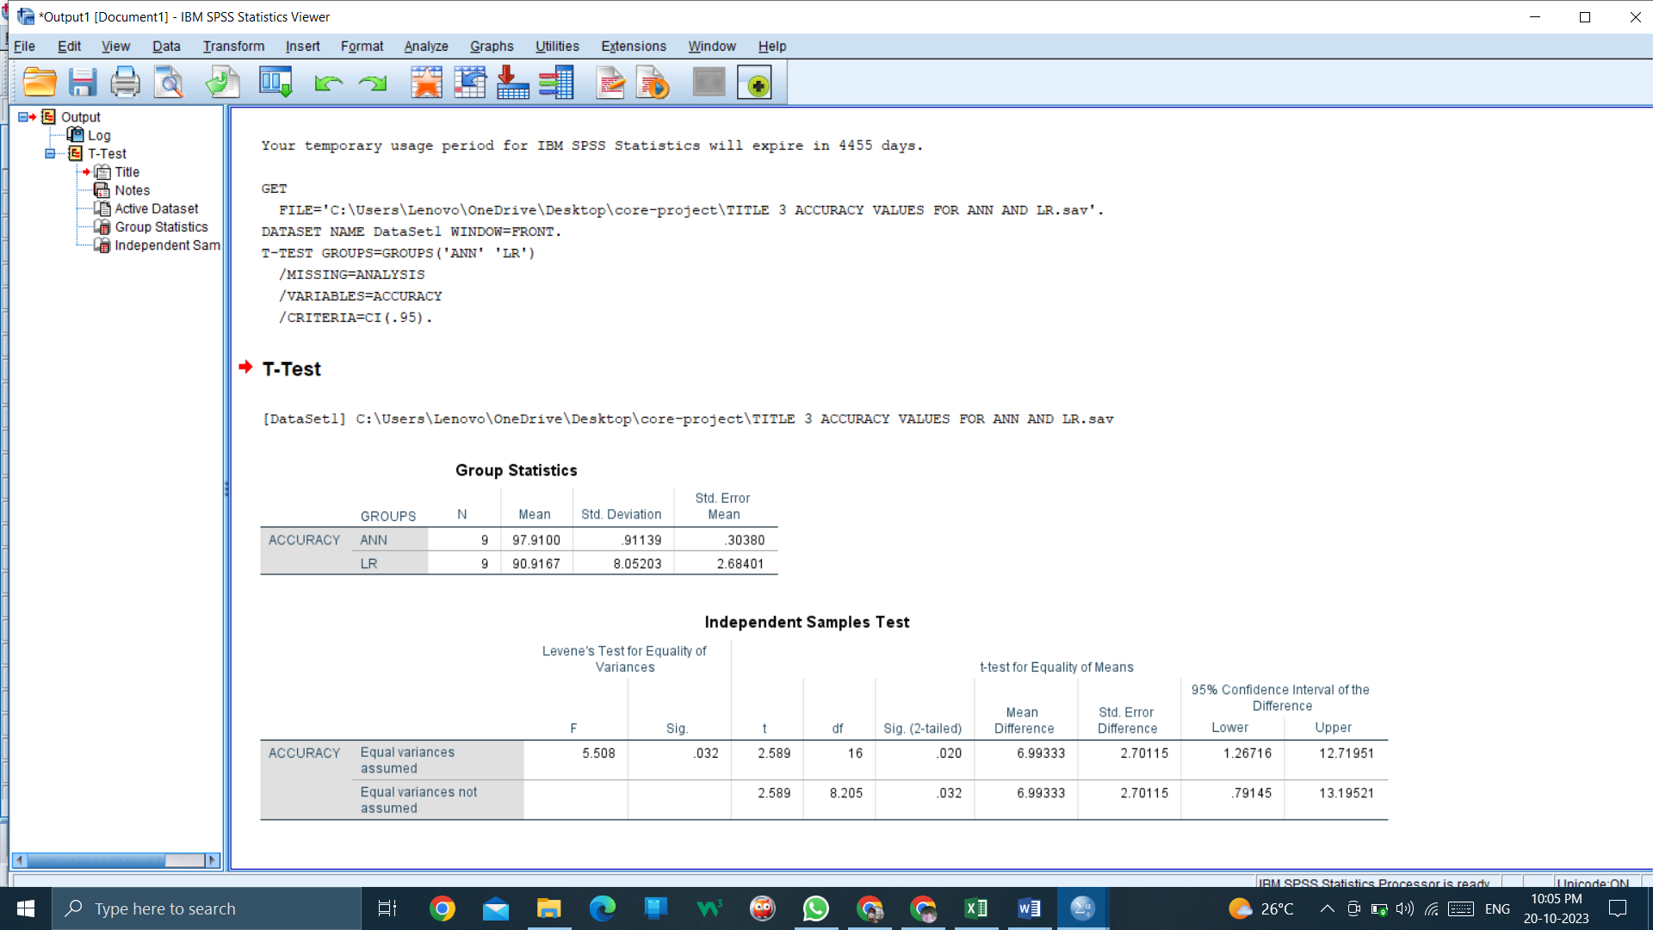

**Table 2- Independent Sample Test**

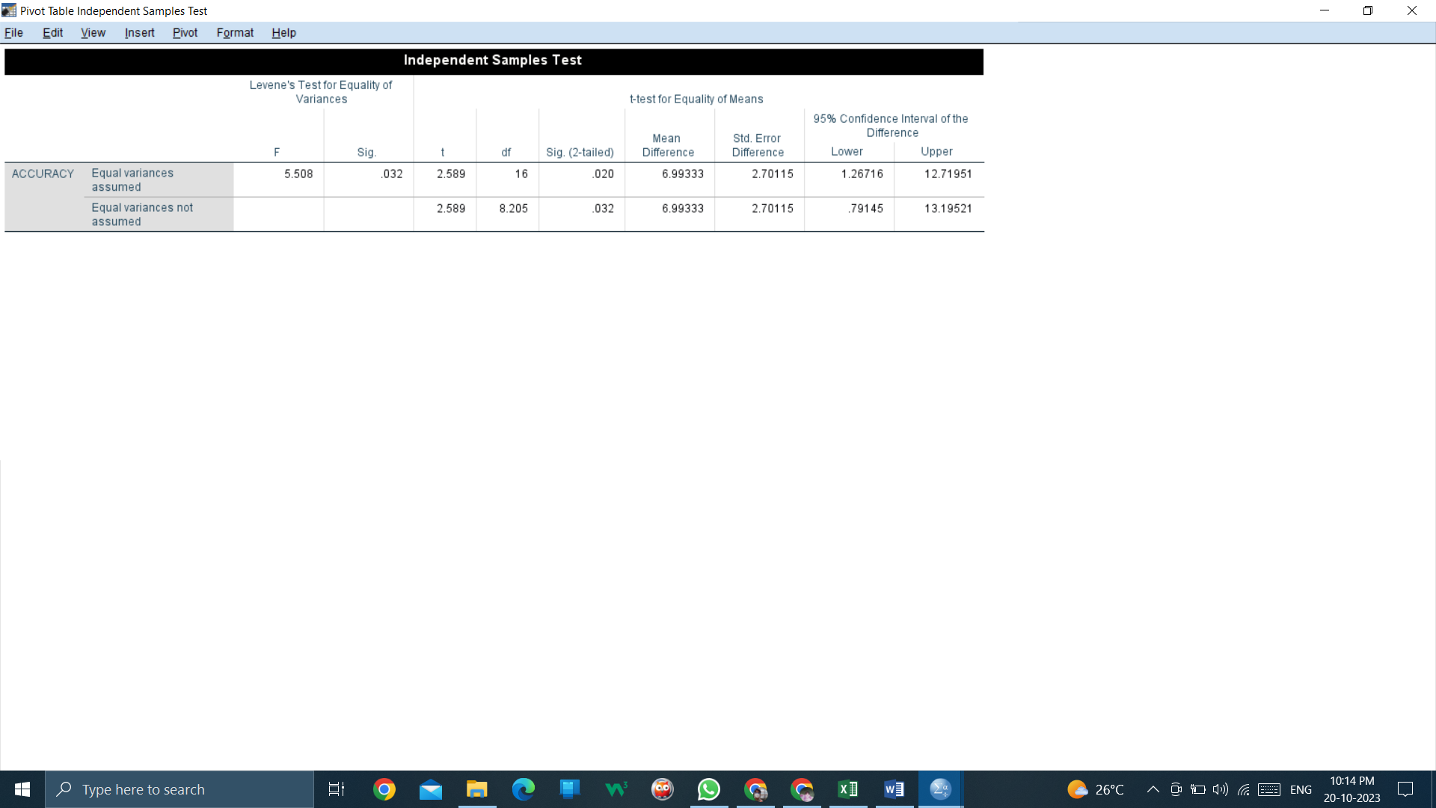

**Table 3-**Bar Graph of Artificial Neural Network [ANN] and Logistic Regressor [LR].

**GGraph:**

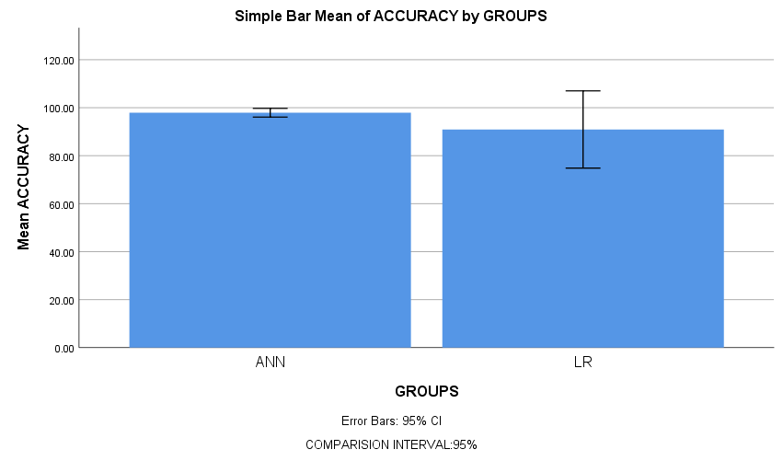

**TITLE-4:-**

**To predict the weather forecast by using Artificial Neural Network [ANN] and comparing over with AdaBoost for improving the accuracy.**

**Table one-**The various datasets Mean, standard deviation and std. Error means of Artificial Neural Network [ANN] and AdaBoost.

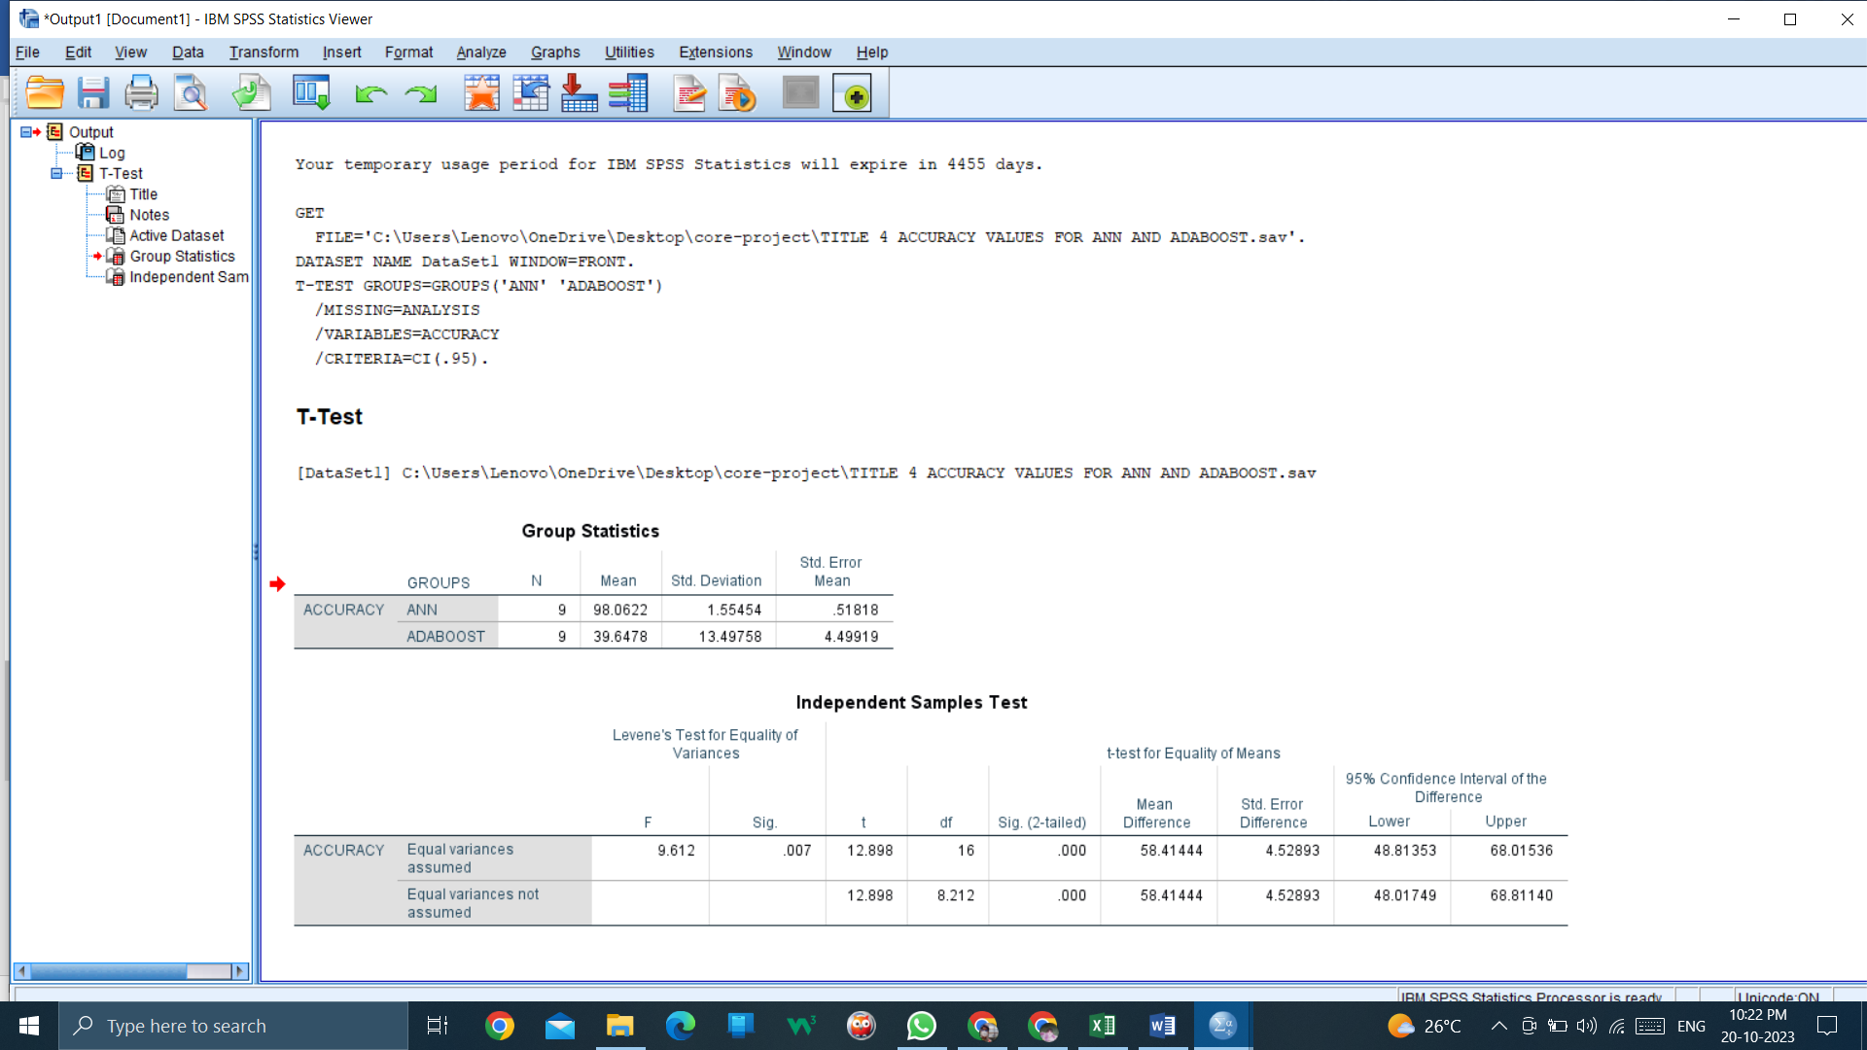

**Table 2- Independent Sample Test**

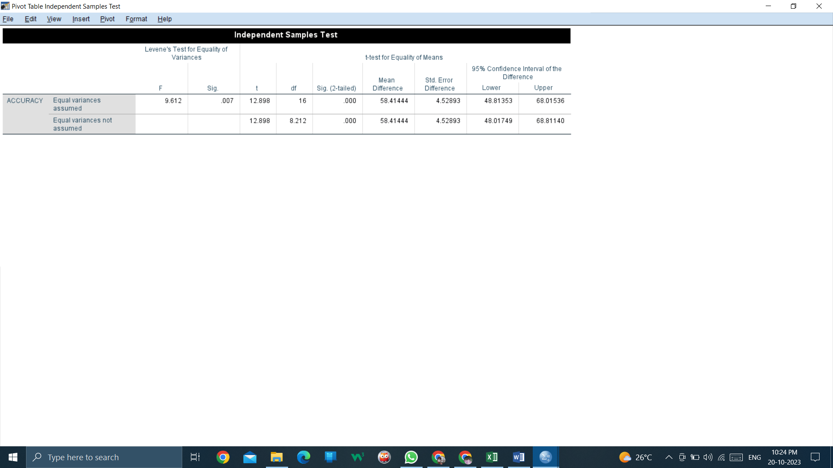

**Table 3-**Bar Graph of Artificial Neural Network [ANN] and AdaBoost.

**Graph:**

